**Lab-04**

**Name of Lab:** To Understand the Working Mechanism of Switch

**Theory:**

Switches are networking devices operating at layer 2 or a data link layer of the OSI model. They connect devices in a network and use packet switching to send, receive or forward data packets or data frames over the network.

A switch has many ports, to which computers are plugged in. When a data frame arrives at any port of a network switch, it examines the destination address, performs necessary checks and sends the frame to the corresponding device(s). It supports unicast, multicast as well as broadcast communications.

**Steps involved in verifying Working Mechanism of Switch**

**Step 1:**

We opened the cisco packet tracer and it looked like figure below which is also the initial phase.

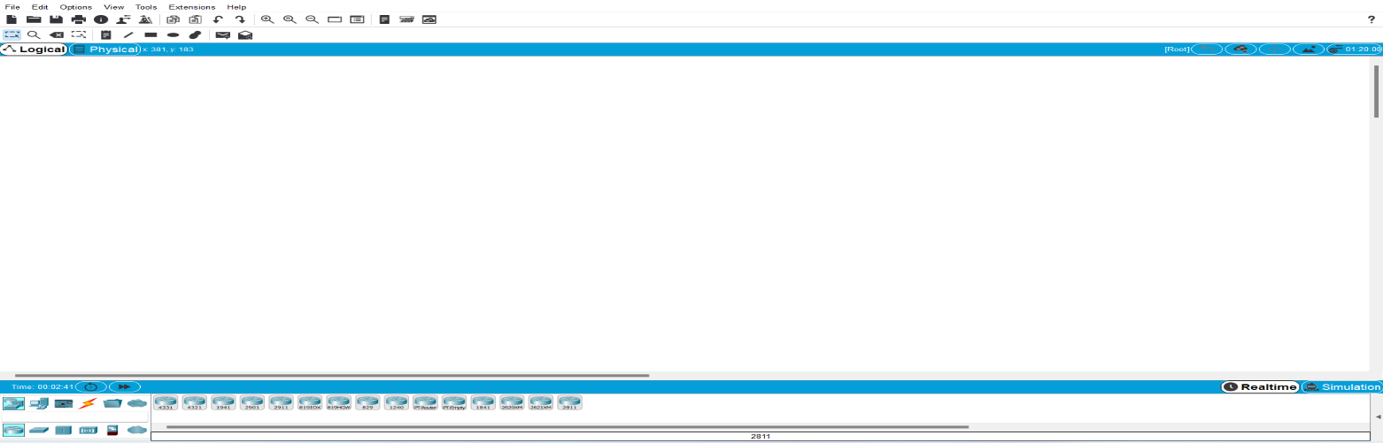

**Step 2:**

Then we added network device in order to establish network using switch and it look like figure below:

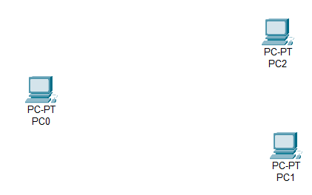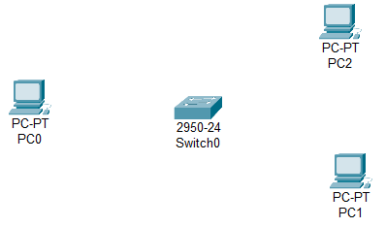

**Step 3:**

Then we connected the devices with each other using straight through wire since we have connected device of different type as figure below:

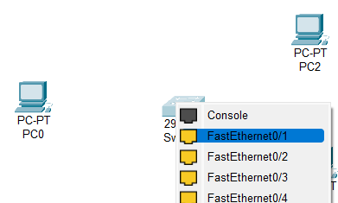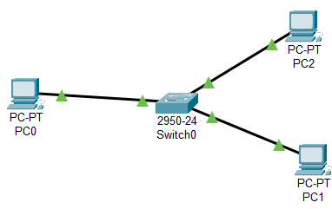

**Step 4:**

In this step we have assigned the all devices with internet protocol address(IP) as shown below:

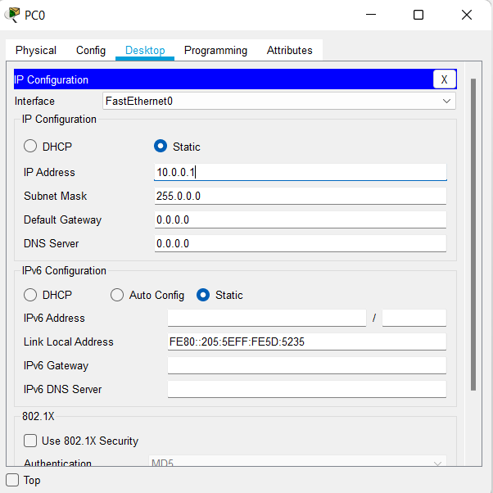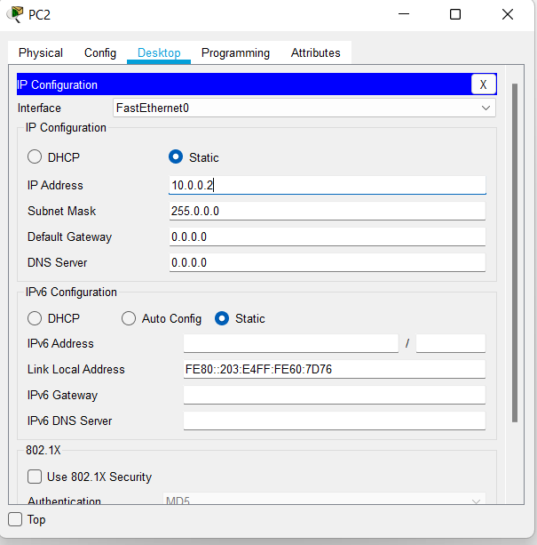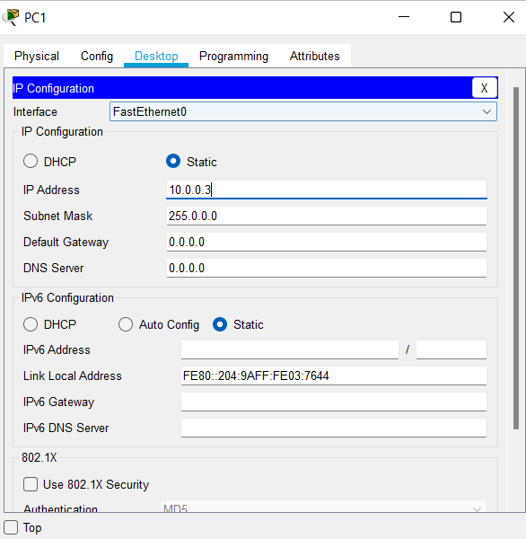

**Step 5:**

In this step we configured all devices IP address as shown below:

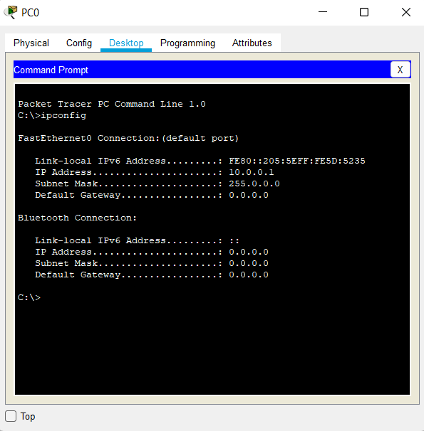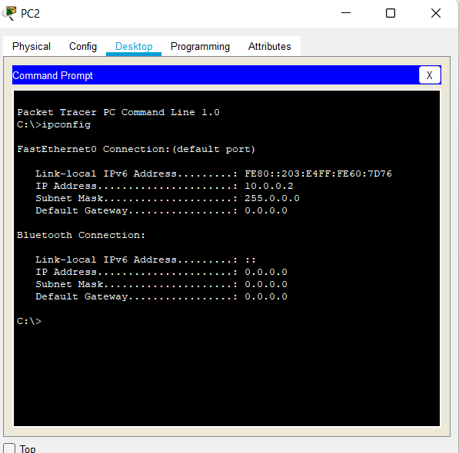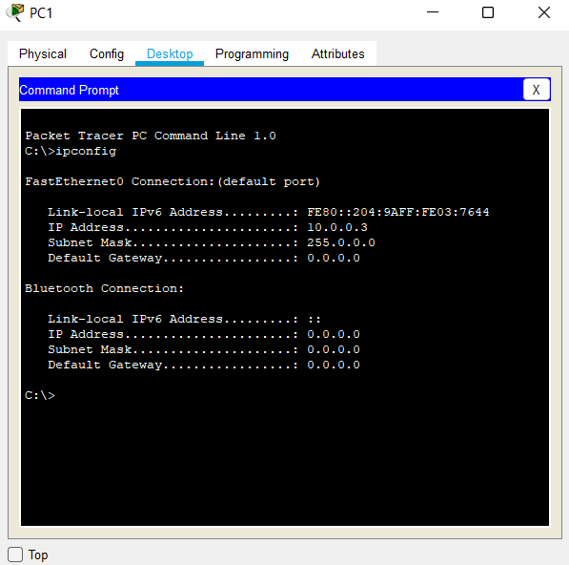

**Step 6:**

In this step we configured the network device i.e. switch as shown below:

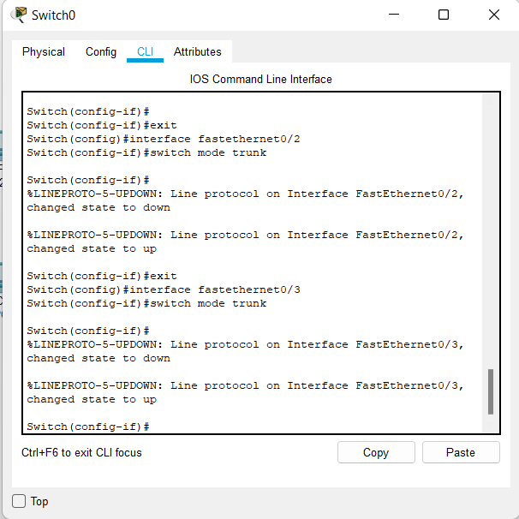

**Step 7:**

Verifying the working mechanism of switch by pinging the device with eachother as shown below:

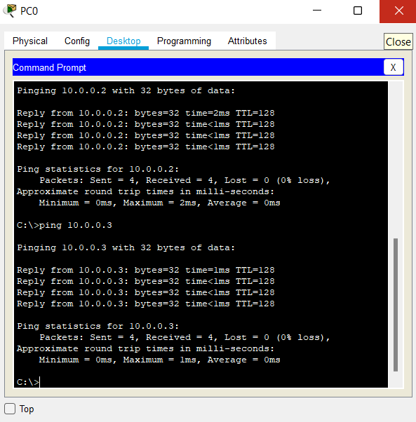

**Step 7:**

Verifying the working mechanism of switch and various steps of **Simulation** are shown below:

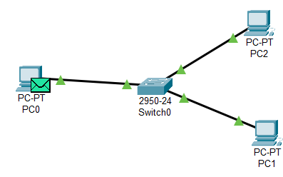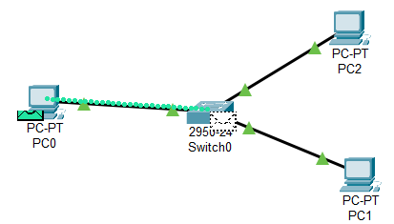

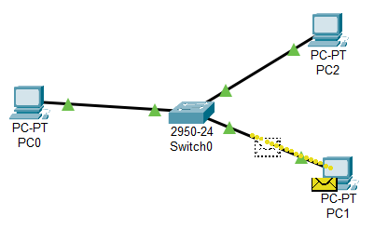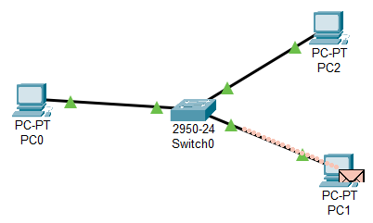

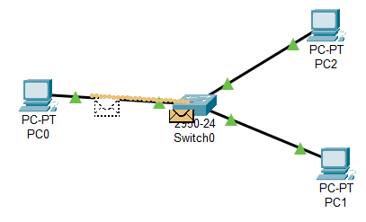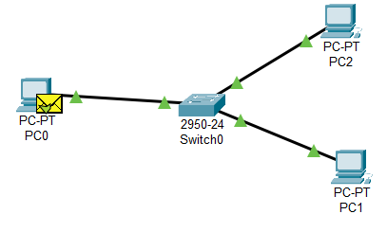

**Conclusion:**

Here in this lab we came to conclude network is constructed using Switch and verified it’s working mechanism with the help of cisco packet tracer.